**Links Imagens**

<https://louveira.portaldacidade.com/noticias/esportes/clubes-de-vinhedo-vao-promover-melhorias-no-campo-da-vila-planalto-2137>



https://encrypted-tbn0.gstatic.com/images?q=tbn:ANd9GcSeZmpM2NuySQQTdBjlGDHPhBZZlxEKhDVTn5XN5aIQeVMna-1AcZANmswWjhD0KcZCros&usqp=CAU

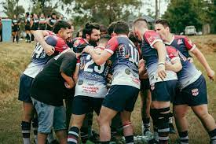

<https://dev.to/stanley/entrega-agil-com-scrum-4bn9>



https://opensource.janestreet.com/incremental/